**Virtual Reality : The Future**

**Sandeep Sahu**

**MCA 1st Sem**

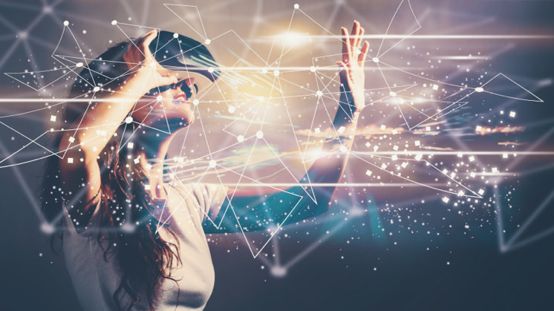

**When we talk about Virtual Reality (VR), many of us think of science fiction films like 'Minority Report'. However, the truth is that nowadays, this technology completely blends in with our daily lives. VR technology is a growing force beyond entertainment and an important tool in education, science, commerce, manufacturing, and more.**

Virtual reality is the use of computer technology to create simulated environments. Virtual reality places the user inside a three-dimensional experience. Instead of viewing a screen in front of them, users are immersed in and interact with 3D worlds. This environment is perceived through a device known as a Virtual Reality headset or helmet. VR allows us to immerse ourselves in video games as if we were one of the characters, learn how to perform heart surgery or improve the quality of sports training to maximize performance.

Another way is watching films, it gives a wider view of a movie and it allows you to see different angles and all the films are 3D. You also use virtual reality for visiting places like, if you don’t have the money to travel, you could purchase a VR headset and take a look at that. That is why virtual reality is an emerging technology today.

Virtual reality goes back farther. It was first studied in the 1800s and in 1838 the first stereoscope which is a device where two photos of the same thing are taken and viewed together creating an impression of death and solidity. It was until the mid 1980s by Jaron Lanier, head of VPL Research started developing gear for virtual reality such as goggles and gloves. Even before 1956 Morton Heilig made the Sensorama which was a simulation of riding a motorcycle where you were able to see the road, fill the vibration, hear the engine, and smell the motor's exhaust.

The very first interactable virtual reality was made in 1968 by Ivan Sutherland and his student Bob Sproull. It was connected to a computer with no camera. Virtual reality is used in many different ways like first gaming and allows you to react more.

According to an article on Forbes, “VR Training Next Generation Of Workers”, potential LASD officers went through a virtual reality training featuring the “VirTra” system that gave trainees an extremely realistic simulation of tackling an altercation. Those that were trained through this system responded that using virtual reality to tackle this objective was “much more realistic than range training” and also got their heart rate up as though it was a real-life scenario. This clearly reflects the benefits of using virtual reality in career training courses as it offers a similar experience to actual reality. Furthermore, in the medical field, virtual reality allows doctors, surgeons, nurses, and other related medical occupations to understand their patient’s bodies better than other technological equipment already present.

With the extended reality (XR) revolution already underway, it’s easy to envision a future in which the lines between the real world and the virtual world become even more blurred than they are today. In the future, it’s likely we’ll experience XR in ways we can’t yet imagine. But, for now, there are plenty of imminent tech advances to look forward to. We’ll have faster, lighter, more affordable VR technology. And advances in smartphone technology (such as better cameras and processors) will mean we can enjoy slicker AR and VR experiences on our phones. And with 5G wireless networks, we'll be able to enjoy them wherever we are in the world.

**LiDAR will bring more realistic AR creations to our phones.** The iPhone and iPad Pro are now equipped with LiDAR technology, and it’s reasonable to expect other devices will follow suit in due course. LiDAR (Light Detection and Ranging) is essentially used to create a 3D map of surroundings, which can seriously boost a device’s AR capabilities. It can provide a sense of depth to AR creations – instead of them looking like a flat graphic. It also allows for *occlusion*, which is where any real physical object located in front of the AR object should, obviously, block the view of it – for example, people's legs blocking out a Pokémon GO character on the street. This is vital for making AR creations appear more rooted in the real world and avoiding clunky AR experiences.

**VR headsets will get smaller, lighter, and incorporate more features.** Hand detection and eye tracking are two prominent examples of the built-in technology that will increasingly be incorporated into VR headsets. Because hand detection allows VR users to control movements without clunky controllers, users can be more expressive in VR and connect with their game or VR experience on a deeper level. And the inclusion of eye-tracking technology allows the system to focus the best resolution and image quality only on the parts of the image that the user is looking at (exactly how the human eye does). This taxes the system less, reduces lag and reduces the risk of nausea.

**We’ll have new XR accessories to deepen the experience further.** One of my favorite examples is robotic boots. Startup Ekto VR has created wearable robotic boots that provide the sensation of walking, to match your movement in the headset, even though you’re actually standing still. The Ekto One robotic boots look a bit like futuristic roller skates except, instead of wheels, they have rotating discs on the bottom, which move to match the direction of the wearer’s movements. In future, accessories like this may be considered a normal part of the VR experience.

**We'll even have full-body haptic suits.** We already have things like haptic gloves, which simulate the feeling of touch through vibrations. But what about full body suits? In fact, full-body suits are already available – the TESLASUIT being one example – but they aren't exactly affordable for everyday VR users. They will probably become more affordable, mainstream, and effective in time, providing yet another leap forward for VR.